**Dönges CrashStay – User Manual**

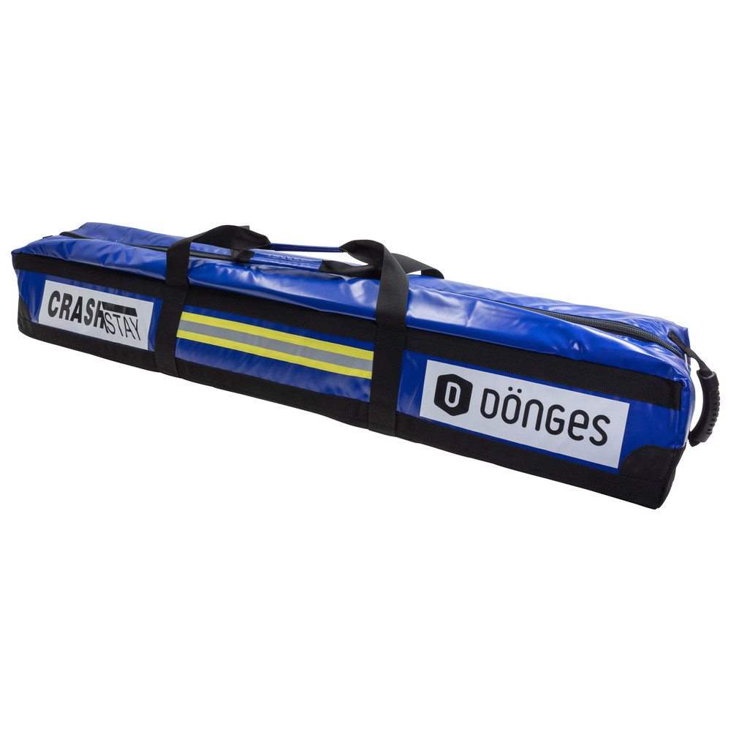



The complete set consisting of:

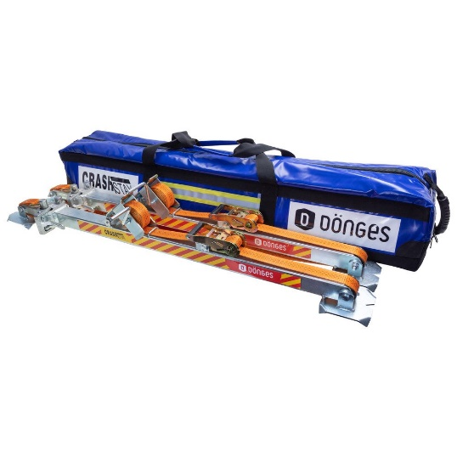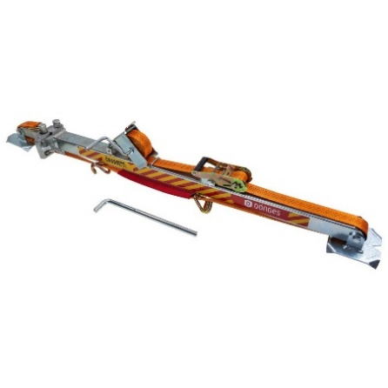

* 2 Supports, working length 1.220 – 2.000 mm
* 2 Operating lever
* 1 Transportation bag

**Support force: max. 1.000 kg per support**

**Permissible tensioning force of the strap max. 1.000 kg**

**ATTENTION:**

**Use CrashStay for stabilisation purposes only!**

**NEVER use CrashStay to lift or spread parts or things!**

**Important preliminary remarks**

* Please read this manual carefully before using CrashStay for the first time and follow all instructions and rules for using CrashStay.
* CrashStay may only be used by qualified personnel who have been instructed beforehand.
* When disposing of CrashStay, the regional disposal regulations must be observed and followed.

**Safety instructions**

* CrashStay may only be used by qualified persons. Uninvolved persons must keep a sufficient safety distance.
* During the use of CrashStay, appropriate protective clothing (work clothes, safety shoes or –boots, gloves, helmet, face shield) must be worn.
* During the stabilisation process, make sure that the supports are not moved as this would endanger the stability. Keep an eye on the surroundings and watch out for electric lines and other obstacles.
* Ensure that the maintenance instructions are followed and always store the operating instructions in the transport bag so that they can be referred to at any time.
* No modifications of any kind may be made to CrashStay, as these will invalidate the warranty. In addition, modifications to the product could result in damage to property or personal injury.
* Only use original spare parts.
* Make sure that CrashStay is securely stored in the transport bag before loading the parts into a vehicle.
* Check that CrashStay is undamaged after each use. If there is visible damage, CrashStay must not be used again. Damaged or missing parts or tension straps must be replaced before the next use.

**Maintenance**

* Clean CrashStay thoroughly after each use. Remove dirt and debris from all parts.
* While cleaning, check all parts for wear or damage.
* Regularly check all screw connections and fixings and ensure that they are tight and secured.
* Lubricate all moving parts regularly.

**Intended purpose**

* CrashStay is primarily intended to be used for stabilising crashed vehicles:
  + Vehicles lying on their side
  + Vehicles lying on the roof
  + Vehicles standing/lying on other vehicles
* For a short time, CrashStay can also be used as a support for other objects such as walls or beams.
* CrashStay can be easily and quickly assembled and disassembled by a trained person.
* Under no circumstances should CrashStay be used for long-term support in continuous use.
* Optimum set-up angle: 25 to 35°.
* If the angle is greater than 35°, the support plate must be additionally secured against slipping.
* Use CrashStay for stabilisation purposes only!
* NEVER use CrashStay to lift or spread parts or things!
* Operating range: 1.220 – 2.000 mm
* Load capacity: 1.000kg per support

**Releasing the tensioning strap**

Pull the release lever in the ratchet handle and at the same time turn the ratchet handle over. Overextend the ratchet handle until it engages at an opening angle of approx. 180°. You can now loosen the tensioning strap.

**Fixing the tensioning strap**

Roll up the part of the tensioning strap that is not needed by help of the hand crank. Now reach into the ratchet handle and tighten the strap by moving the ratchet handle back and forth evenly, which will tighten the strap.

**Adjusting and fixing the length of the CrashStay support**

* Push the locking lever towards the support and keep it pressed in this position
* The extendable part of the support is now free to move
* Pull out the extendable part of the support until the support has the desired length
* Now release the locking lever
* By means of the operating lever you can make a fine adjustment of the support length
* To do this, place the control lever on the side of the fine adjustment shaft (directly next to the locking lever) and turn in the desired direction to lengthen or shorten the support
* Then place the operating lever on the locking shaft (opposite the fine adjustment shaft) and turn until the locking shaft is tight.

**Stabilising a vehicle lying on its side**

1. Wedge the vehicle between the upper side and the ground with support lumber.
2. Position the first CrashStay support on the underside of the vehicle at an angle of approx. 25° to 35°.
3. Place your feet on the foot plate and extend the support at an angle until the head plate finds support at a suitable point on the top of the vehicle. If necessary, create a hole in the underbody with a suitable tool so that the head plate can be securely attached. Also fix the ground plate of support if necessary.
4. Adjust the length of the support and fine adjust it using the control lever on the fine adjustment shaft until the support fits perfectly btw. ground and head end.
5. Turn the locking shaft into the "TIGHT" direction with the operating lever, using sufficient hand force.
6. Loosen the tensioning belt slightly and pull it until you have enough belt length. Now pull the free-running hook of the belt towards the vehicle and hook it in a suitable place.
7. Tighten the belt with the ratchet.
8. You have now formed a stable triangle.
9. Repeat steps 2 - 8 with the second CrashStay support in a second suitable position.

Check the position of the tensioning pulley in the ratchet before use. The slot should be parallel to the support so that the belt can run freely when pulled out. After use, the belt is released by turning the ratchet handle over and pulling the release lever at the same time. Wind the free-running belt back onto the roller after using the support.

**Observe safety instructions during use**

* Always secure the head and foot plate of the CrashStay support against slipping.
* During use, always check the structure and stability by shaking it gently.
* The CrashStay support only secures the vehicle against tipping over, but not against sliding in parallel longitudinal direction.
* Observe the system during use and react in case of possible slipping by re-tensioning or re-securing, if necessary by re-attaching.
* The tensioning strap must not come into contact with hot surfaces. If necessary, protect the belt with suitable covers.
* Secure the site of use to avoid tripping over the support system.

Stand: 04. Februar 2021

JH